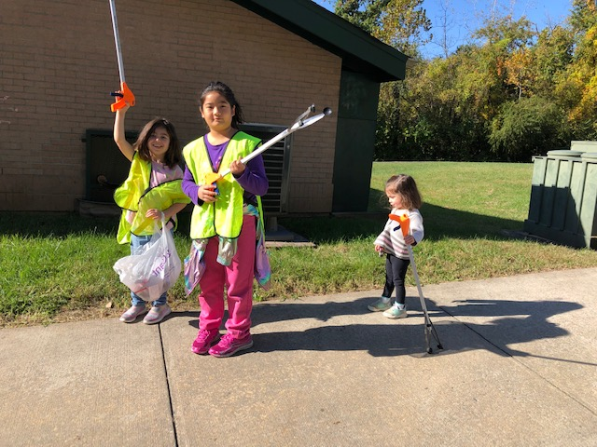
President’s Corner: Lan Tsubata

We are in our membership drive, so you may have someone coming to your house to sign you up for the West Lanham Hills Citizens Association. Anyone 18 and older who resides in the neighborhood is eligible. The dues are $2, but senior citizens are free. The WLHCA carries out the many volunteer activities for the neighbors and communicates our wishes with the County and other organizations. Members can vote, propose activities and address the meetings. Please join!
A community clean up will take place Saturday, Oct. 21 from 10 am. to 1 p.m. Two dumpsters will be available. Volunteers please meet at the Park building and community service hours will be given.

We need volunteers to help beautify the neighborhood’s entrance sign. It needs pruning, trash picked up, and lighting solution. If you are interested to help, please contact Sarah Tsubata, 785-341-5042 or email sarahtsubata@gmail.com

Got the Christmas Spirit?
Our annual Santa’s Workshop is a few months away. Usually, this involves arts and crafts projects, food, and photos with Santa. The past two years, we invited neighbors to bring household items they were willing to give away, for others to receive.
This year our main coordinators will not be able to organize it. So, we are looking for anybody that would like to help to coordinate a holiday event.
This event could be a photo with Santa and some food, or pancakes with Santa, or Christmas caroling and hot coca. Whatever it is, the purpose is to bring community. The event can be very simple.
So, if you would like to help organize the holiday event, please contact the president, Lan Tsubata, 301-442-3517 or lantsubata@yahoo.com.

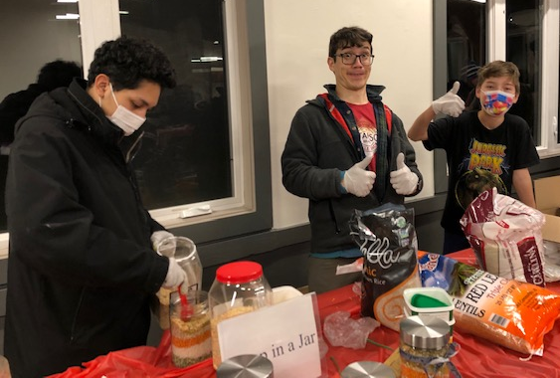

MNCPPC is hiring!
If you are looking for job, the MNCPPC is hiring. Job positions for everything are available. To apply go to, https://www.mncppc.org/165/Employment.

Reserving the park building
Are you planning an event (baby shower, birthday party, etc.) and would like to reserve the park building? To reserve the building, you will need to call the park reservation permit office. Their phone number is 301-699-2400. Their website is www.pgparks.com. They will be able to help you.

Homeowner Property Tax Credit
Residents 65 and older who have owned their homes for at least 10 years, are eligible for a 5-year, 20% Property Tax Credit. The limit on the property’s value is $500,000, indexed upward annually by 3% for normal inflation. The Property Tax Credit will remain in place for a period of up to five years. Apply online at: http://www.taxcredits.sdat.maryland.gov/


Neighborhood power sessions:
The Community park building will be reserved for educational or civic activities.
In past we had Solar City informative class, English as second language (ESL), Occupational Safety and Health administration (OSHA) training, Capital One: Money Matters, Getting hired with Olivia Hunter, and Make a Resume with Kate Tsubata.
If you have some information or training to offer the neighbors, please contact Sarah Tsubata, Board Secretary, to be put on the schedule. (sarahtsubata@gmail.com).

Yard Work Needed?
If you are looking to hire a teen to do yard work for you this summer Dojoon Lee is ready to work for you! He offers mowing, weeding, raking and other yard services. For pricing and scheduling please call 301-442-3517 or email djlee1155@gmail.com
Free Pet Inoculations:
A Drive Up FREE Clinic for dogs and cats at the Wayne Curry Sports and Learning Complex will take place Monday, May 8, 2023 from 10 AM to 3 PM, rain or shine, providing:
- Shots for Rabies and Distemper
- Free Pet licenses
- Microchipping
Pets must be at least 4 months old, on a leash or in a carrier. Drivers stay in the car; pets are removed to perform the vaccination.
Info: pgcpetvaccineclinicmay2023.eventbrite.com

SLOW DOWN!!!
The school year has started. Young students are waiting at the bus stops. If the bus has a red sign out, DO NOT pass the bus. The purpose is to keep our young students safe from cars.
Please slow down when you are coming down the hills. We want to keep everyone safe and our pets.

Check www.westlanhamhills.com for announcements or alerts, as well as service providers in the community. The Facebook page, @westlanhamhillsmd also has breaking news and urgent information.

